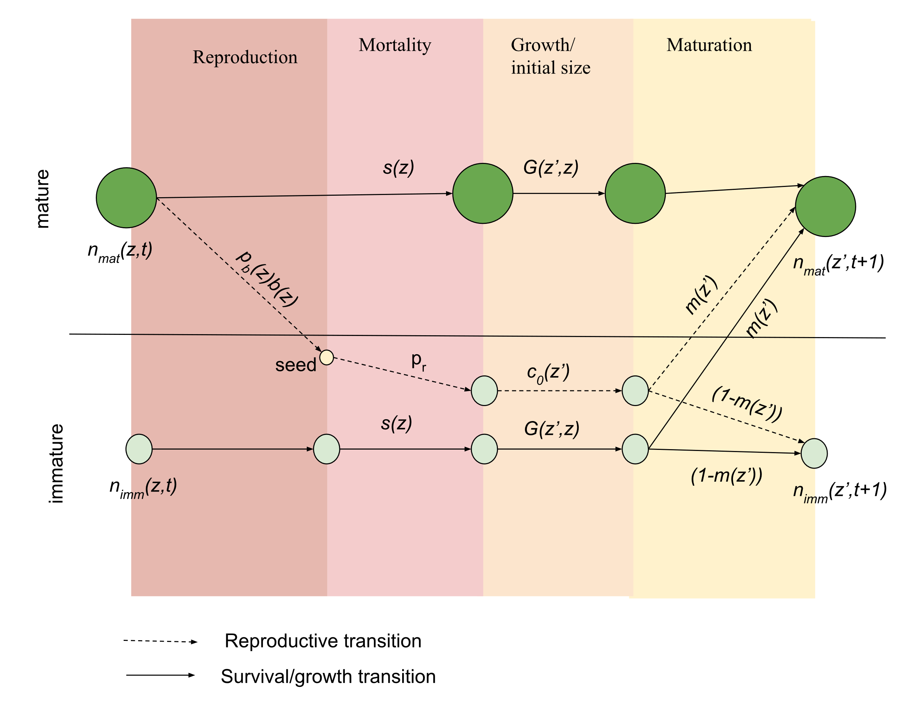

# MPM

## Discretised Survival/growth

#### Immature to immature

$$u_{ij}= s\left(z_{\left[L_{j},U_{j}\right]}\right)G\left({z^{'}}_{\left[L_{i},U_{i}\right]},z_{\left[L_{j},U_{j}\right]}\right)\left(1-m\left({z'}_{\left[L_{i},U_{i}\right]}\right)\right)=\frac{\int_{L_{j}}^{U_{j}}{n_{imm}\left(z\right)s\left(z\right)dz}}{\int_{L_{j}}^{U_{j}}{n_{imm}\left(z\right)dz}} \frac{\int_{L_{i}}^{U_{i}}{\int_{L_{j}}^{U_{j}}{n_{imm}\left(z\right)s\left(z\right)G\left(z^{'},z\right)dzdz^{'}}}}{\int_{L_{j}}^{U_{j}}{n_{imm}\left(z\right)s\left(z\right)dz}} \frac{\int_{L_{i}}^{U_{i}}{\int_{L_{j}}^{U_{j}}{n_{imm}\left(z\right)s\left(z\right)G\left(z^{'},z\right)\left(1-m\left(z^{'}\right)\right)dzdz^{'}}}}{\int_{L_{i}}^{U_{i}}{\int_{L_{i}}^{U_{j}}{n_{imm}\left(z\right)s\left(z\right)G\left(z^{'},z\right)dzdz^{'}}}}= \frac{\int_{L_{i}}^{U_{i}}{\int_{L_{j}}^{U_{j}}{n_{imm}\left(z\right)s\left(z\right)G\left(z^{'},z\right)\left(1-m\left(z^{'}\right)\right)dzdz^{'}}}}{\int_{L_{j}}^{U_{j}}{n_{imm}\left(z\right)dz}}$$

#### Immature to mature

$$u_{ij}= s\left(z_{\left[L_{j},U_{j}\right]}\right)G\left({z^{'}}_{\left[L_{i},U_{i}\right]},z_{\left[L_{j},U_{j}\right]}\right)m\left({z'}_{\left[L_{i},U_{i}\right]}\right)=\frac{\int_{L_{j}}^{U_{j}}{n_{imm}\left(z\right)s\left(z\right)dz}}{\int_{L_{j}}^{U_{j}}{n_{imm}\left(z\right)dz}} \frac{\int_{L_{j}}^{U_{j}}{\int_{L_{i}}^{U_{i}}{n_{imm}\left(z\right)s\left(z\right)G\left(z^{'},z\right)dzdz^{'}}}}{\int_{L_{j}}^{U_{j}}{n_{imm}\left(z\right)s\left(z\right)dz}} \frac{\int_{L_{j}}^{U_{j}}{\int_{L_{i}}^{U_{i}}{n_{imm}\left(z\right)s\left(z\right)G\left(z^{'},z\right)m\left(z^{'}\right)dzdz^{'}}}}{\int_{L_{ij}}^{U_{j}}{\int_{L_{i}}^{U_{i}}{n_{imm}\left(z\right)s\left(z\right)G\left(z^{'},z\right)dzdz^{'}}}}=\frac{\int_{L_{j}}^{U_{j}}{\int_{L_{i}}^{U_{i}}{n_{imm}\left(z\right)s\left(z\right)G\left(z^{'},z\right)m\left(z^{'}\right)dzdz^{'}}}}{\int_{L_{j}}^{U_{j}}{n_{imm}\left(z\right)dz}}$$

#### Mature to mature

$$u_{ij}= s\left(z_{\left[L_{j},U_{j}\right]}\right)G\left({z^{'}}_{\left[L_{i},U_{i}\right]},z_{\left[L_{j},U_{j}\right]}\right)= \frac{\int_{L_{j}}^{U_{j}}{n_{mat}\left(z\right)s\left(z\right)dz}}{\int_{L_{j}}^{U_{j}}{n_{mat}\left(z\right)dz}} \frac{\int_{L_{i}}^{U_{i}}{\int_{L_{j}}^{U_{j}}{n_{mat}\left(z\right)s\left(z\right)G\left(z^{'},z\right)dzdz^{'}}}}{\int_{L_{j}}^{U_{j}}{n_{mat}\left(z\right)s\left(z\right)dz}}= \frac{\int_{L_{i}}^{U_{i}}{\int_{L_{j}}^{U_{j}}{n_{mat}\left(z\right)s\left(z\right)G\left(z^{'},z\right)dzdz^{'}}}}{\int_{L_{j}}^{U_{j}}{n_{mat}\left(z\right)dz}}$$

## Discretised Fecundity

#### Mature to immature

$$f_{ij}= p_{b}\left(z_{\left[L_{j},U_{j}\right]}\right)b\left(z_{\left[L_{j},U_{j}\right]}\right)p_{r} c_{0}\left({z^{'}}_{\left[L_{i},U_{i}\right]}\right)\left(1-m\left({z^{'}}_{\left[L_{i},U_{i}\right]}\right)\right)=\frac{\int_{L_{j}}^{U_{j}}{n_{mat}\left(z\right)p_{b}(z)dz}}{\int_{L_{j}}^{U_{j}}{n_{mat}\left(z\right)dz}} \frac{\int_{L_{j}}^{U_{j}}{n_{mat}\left(z\right)p_{b}(z)b(z)dz}}{\int_{L_{j}}^{U_{j}}{n_{mat}\left(z\right)p_{b}(z)dz}} \frac{\int_{L_{j}}^{U_{j}}{n_{mat}\left(z\right)p_{b}(z)b(z)p_{r}dz}}{\int_{L_{j}}^{U_{j}}{n_{mat}\left(z\right)p_{b}(z)b(z)dz}} \frac{\int_{L_{i}}^{U_{i}}{\int_{L_{j}}^{U_{j}}{n_{mat}\left(z\right)p_{b}(z)b(z){p_{r}c}_{0}(z')dzdz^{'}}}}{\int_{L_{j}}^{U_{j}}{n_{mat}\left(z\right)p_{b}(z)b(z)p_{r}dz}} \frac{\int_{L_{i}}^{U_{i}}{\int_{L_{j}}^{U_{j}}{n_{mat}\left(z\right)p_{b}\left(z\right)b\left(z\right)p_{r}c_{0}\left(z'\right)\left(1-m\left(z'\right)\right)dzdz^{'}}}}{\int_{L_{i}}^{U_{i}}{\int_{L_{j}}^{U_{j}}{n_{mat}\left(z\right)p_{b}(z)b(z)p_{r}c_{0}(z')dzdz^{'}}}}= \frac{\int_{L_{i}}^{U_{i}}{\int_{L_{j}}^{U_{j}}{n_{mat}\left(z\right)p_{b}\left(z\right)b\left(z\right)c_{0}\left(z'\right)\left(1-m\left(z'\right)\right)dzdz^{'}}}}{\int_{L_{j}}^{U_{j}}{n_{mat}\left(z\right)dz}}$$

#### Mature to mature

$$f_{ij}= p_{b}\left(z_{\left[L_{j},U_{j}\right]}\right)b\left(z_{\left[L_{j},U_{j}\right]}\right)p_{r} c_{0}\left({z^{'}}_{\left[L_{i},U_{i}\right]}\right)m\left({z^{'}}_{\left[L_{i},U_{i}\right]}\right)=\frac{\int_{L_{j}}^{U_{j}}{n_{mat}\left(z\right)p_{b}(z)dz}}{\int_{L_{j}}^{U_{j}}{n_{mat}\left(z\right)dz}} \frac{\int_{L_{j}}^{U_{j}}{n_{mat}\left(z\right)p_{b}(z)b(z)dz}}{\int_{L_{j}}^{U_{j}}{n_{mat}\left(z\right)p_{b}(z)dz}} \frac{\int_{L_{j}}^{U_{j}}{n_{mat}\left(z\right)p_{b}(z)b(z)p_{r}dz}}{\int_{L_{j}}^{U_{j}}{n_{mat}\left(z\right)p_{b}(z)b(z)dz}} \frac{\int_{L_{i}}^{U_{i}}{\int_{L_{j}}^{U_{j}}{n_{mat}\left(z\right)p_{b}(z)b(z){p_{r}c}_{0}(z')dzdz^{'}}}}{\int_{L_{j}}^{U_{j}}{n_{mat}\left(z\right)p_{b}(z)b(z)p_{r}dz}} \frac{\int_{L_{i}}^{U_{i}}{\int_{L_{j}}^{U_{j}}{n_{mat}\left(z\right)p_{b}\left(z\right)b\left(z\right)p_{r}c_{0}\left(z'\right)m\left(z'\right)dzdz^{'}}}}{\int_{L_{i}}^{U_{i}}{\int_{L_{j}}^{U_{j}}{n_{mat}\left(z\right)p_{b}(z)b(z)p_{r}c_{0}(z')dzdz^{'}}}}= \frac{\int_{L_{i}}^{U_{i}}{\int_{L_{j}}^{U_{j}}{n_{mat}\left(z\right)p_{b}\left(z\right)b\left(z\right)c_{0}\left(z'\right)m\left(z'\right)dzdz^{'}}}}{\int_{L_{j}}^{U_{j}}{n_{mat}\left(z\right)dz}}$$